IoT-Based Water Quality Monitoring System for Swimming Pool
Muhamad Khairul Ali Hassan¹*, Muhamad Naqib Mohd Shukri¹*, Fathinul Syahir Ahmad Saad¹, Sukhairi Sudin¹, Khairul Salleh Basaruddin², Muhammad Juhairi Aziz Safar¹, Shafriza Nisha Basah¹, Haniza Yazid³, Mohd Hanafi Mat Som³, Zhongjie Long⁴
Faculty of Electrical Engineering & Technology,
Universiti Malaysia Perlis, Kampus Pauh Putra, Arau, Perlis, 02600, MALAYSIA
Faculty of Mechanical Engineering & Technology,
Universiti Malaysia Perlis, Kampus Pauh Putra, Arau, Perlis, 02600, MALAYSIA
Faculty of Electronic Engineering & Technology,
Universiti Malaysia Perlis, Kampus Pauh Putra, Arau, Perlis, 02600, MALAYSIA
School of Electromechanical Engineering,
Beijing Information Science & Technology University, 100192, CHINA

*Corresponding Author: khairulhassan@unimap.edu.my
DOI: https://doi.org/10.30880/ijie.2025.17.02.019
Article Info | Abstract
Received: 5 October 2024  Accepted: 22 June 2025  Available online: 28 July 2025 | A swimming pool is a recreational facility where people relax and refresh themselves. However, maintaining good water quality is essential, as poor water conditions can negatively impact users' health. In public swimming pools, operators typically rely on manual devices to measure pH and chlorine levels, making it challenging to maintain consistent water quality. This can lead to potential skin irritation and other health issues. Therefore, an automated water quality monitoring system has been developed to continuously track and maintain pool water quality by measuring pH, chlorine concentration, turbidity, and temperature to ensure a safe and comfortable swimming environment. The system was tested on several swimming pools with varying water conditions, evaluating key parameters such as pH, Total Dissolved Solids (TDS), turbidity, and temperature. The analysis of results demonstrates that the developed system effectively and accurately measures these parameters, providing reliable data for maintaining optimal water quality.
Keywords
Swimming pool, water quality, monitoring system, Total Dissolved Solids (TDS), pH, chlorine concentration, water turbidity
- Introduction
Smart pool water quality solutions enable pool owners and managers to efficiently monitor and maintain water chemistry. These systems utilize sensors and other devices to track key parameters such as pH, chlorine levels, and temperature in real-time. When imbalances are detected, they alert users and provide instant feedback, ensuring necessary adjustments are made promptly.
One of the main benefits of a smart water quality system is its ability to maintain a safe and comfortable swimming environment. Proper pool water treatment helps prevent the growth of harmful germs and algae, reducing health risks for swimmers. Additionally, maintaining balanced water chemistry not only preserves the pool’s structural materials but can also enhance their durability. By automating multiple maintenance tasks, smart water quality devices save time and money for pool owners. These systems can send alerts and even automatically dispense chemicals when needed, eliminating the need for frequent manual testing and adjustments. Ultimately, smart water quality solutions simplify pool upkeep, ensuring optimal water conditions while enhancing convenience and safety for users.
- Background Study
  - Parameter Needed for Swimming Pools
Water irritancy can be influenced by factors such as pH, hardness, osmolarity, temperature, and the loss of stratum corneum moisturizing components. Water chemistry also plays a crucial role, as calcium-rich water may cause skin irritation [1,2]. The Centers for Disease Control and Prevention (CDC) recommends maintaining a pool’s pH between 7.2 and 7.8 to preserve chlorine’s germ-killing effectiveness and minimize eye and skin discomfort for swimmers [3,4].
Chlorine is the most commonly used disinfectant in swimming pools and drinking water. Sodium hypochlorite, a chlorine-based compound primarily used in textile and paper production, is widely utilized for water disinfection [5]. In swimming pools, chlorine effectively eliminates waterborne bacteria, viruses, and other harmful microorganisms, preventing serious diseases. However, free chlorine disinfection can produce harmful byproducts. To mitigate this, the World Health Organization (WHO) recommends maintaining free chlorine levels between 3 and 5 ppm in swimming pools. Many countries have also established legal limits, such as Italy, where pool water must maintain chlorine levels between 0.7 and 1.5 ppm [6].
Temperature regulation is also essential for swimmer safety. The recommended temperature range for outdoor pools is 25–28°C, which is approximately 10°C below body temperature. Water temperatures below 15°C can lead to hypothermia, while excessively warm water can hinder natural cooling, potentially causing overheating [7].
  - Swimming Pool Algae and Prevention
Algae are aquatic plants that can rapidly develop in swimming pools when nutrients such as phosphorus and nitrogen, along with spores from natural and environmental sources, enter the water. These elements can be introduced through wind, human activity, or animals, leading to algae accumulation [8-10]. The first signs of algae growth in a pool include turbid, milky, or foamy water and slippery pool surfaces. Factors such as low chlorine levels, heavy rainfall, and high temperatures in outdoor pools can further promote algae growth.
To effectively prevent algae formation, maintaining proper water chemistry is essential. The recommended parameters for algae prevention include:
- Free chlorine: 1 - 4 ppm
- pH level: 7.2 - 7.6
- Alkalinity: 80 - 150 ppm
- Calcium hardness: 200 - 275 ppm

Regular monitoring and balancing of these parameters help minimize the risk of algae growth, ensuring a clean and safe swimming environment.
  - Total Dissolved Solids (TDS) Value in Swimming Pool
Total Dissolved Solids (TDS) values are commonly used to assess the quality of drinking water, determining its suitability for consumption and defining mineral content in hard water. In swimming pools, TDS levels play a crucial role in maintaining chemical balance [11-13]. If the dissolved substance concentration is too low, it can lead to algae growth. Conversely, excessive chemical substances can result in a milky-white layer forming on the water surface.
TDS values are measured in parts per million (ppm). For swimming pools, the minimum recommended TDS level is 600 ppm, while the ideal range falls between 800 ppm and 1200 ppm. The maximum acceptable TDS value is approximately 1500 to 2000 ppm, as outlined by the Environmental Protection Agency (EPA). Maintaining proper TDS levels helps ensure clean and balanced pool water, preventing water quality issues.
  - Turbidity Value (NTU) for Swimming Pool
Turbidity in water is measured using Nephelometric Turbidity Units (NTU), which quantify the presence of suspended particles that scatter light. Higher turbidity levels indicate the presence of impurities, such as dirt, algae, and organic matter, which can affect water clarity and hygiene.
According to the National Sanitation Foundation (NSF) Standard, the recommended turbidity level for swimming pool water is 0.5 NTU, a threshold considered "crystal clear" and safe for swimmers [14-15]. Maintaining low turbidity is essential for ensuring proper water filtration, preventing bacterial growth, and optimizing the effectiveness of disinfectants like chlorine. If turbidity levels exceed the standard, pool water may appear cloudy, signaling inadequate filtration or chemical imbalances. Regular monitoring and maintenance of turbidity levels help sustain clean, safe, and visually appealing swimming conditions.
- Methodology
  - Flowchart of the System
Fig. 1 illustrates the flowchart of the system process in this project. The system consists of multiple sensors submerged in the swimming pool water to measure key water quality parameters, including pH level, turbidity, Total Dissolved Solids (TDS), and temperature. These sensors continuously collect data, which is then processed by the system to analyze and determine water conditions.
Once the data is gathered, it is transmitted to a cloud server via Wi-Fi, enabling real-time monitoring and storage for future analysis. The processed data is then displayed on both a dedicated website and a mobile application, allowing users such as pool owners or facility managers to access water quality information remotely. Through this system, users can monitor fluctuations in water parameters and take necessary actions if any values exceed the recommended safety thresholds.
To ensure continuous and up-to-date water quality monitoring, the system operates in a loop, repeatedly collecting new sensor readings and updating the displayed results in real time. This automated approach not only reduces the need for manual water testing but also enhances the efficiency and accuracy of pool maintenance, ensuring a safer and more comfortable swimming environment.
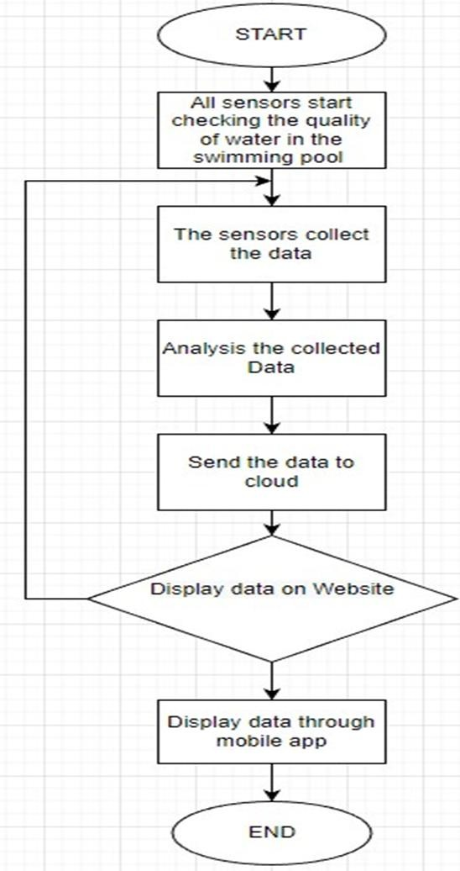
No
Yes
Fig. 1 Flowchart of project
  - Microcontroller
ESP32, as shown in Fig. 2, is a powerful and cost-effective System-on-Chip (SoC) microcontroller developed by Espressif Systems, known for its versatility in IoT applications [16,17]. It is the successor to the widely used ESP8266 SoC and offers significant improvements in performance, connectivity, and power efficiency.
The ESP32 is available in both single-core and dual-core variations, powered by Tensilica’s 32-bit Xtensa LX6 microprocessor. One of its standout features is the integration of Wi-Fi and Bluetooth connectivity, making it ideal for applications requiring wireless communication, such as real-time data transmission in smart monitoring systems. The dual-core version enhances multitasking capabilities, allowing the microcontroller to efficiently handle multiple tasks simultaneously, such as data acquisition, processing, and communication.
Apart from its connectivity features, the ESP32 is equipped with multiple GPIO pins, analog-to-digital converters (ADC), digital-to-analog converters (DAC), and communication interfaces like SPI, I2C, and UART, enabling seamless integration with a variety of sensors and peripherals. Additionally, it supports low-power modes, making it suitable for battery-operated applications where energy efficiency is a priority.
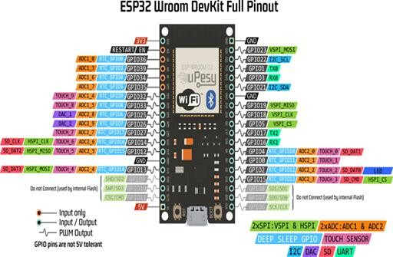
In this project, the ESP32 acts as the central processing unit, collecting data from water quality sensors (pH, turbidity, TDS, and temperature) and transmitting it to a cloud server via Wi-Fi for real-time monitoring. Its built-in capabilities allow for continuous and efficient operation, ensuring reliable data acquisition and processing for maintaining optimal swimming pool water quality.
Fig. 2 ESP32 Wroom Dev Board
  - Circuit Diagram
The circuit connection for this project consists of three analog sensors—a pH sensor, a turbidity sensor, and a TDS (Total Dissolved Solids) sensor—all of which are connected to the Analog-to-Digital Converter (ADC) pins of the ESP32. These sensors generate analog signals that represent real-world measurements, such as pH level, water clarity, and dissolved solid concentration. Since the ESP32 operates digitally, the ADC pins play a crucial role in converting these analog signals into digital values for further processing. This conversion allows the microcontroller to analyze the data and transmit it for real-time monitoring.
In addition to the analog sensors, a DS18B20 temperature sensor is integrated into the system. Unlike the other sensors, the DS18B20 is a digital temperature sensor that communicates using the 1-Wire protocol. This allows it to be connected to a normal digital I/O pin on the ESP32, reducing the number of required connections and enabling multiple temperature sensors to be used on a single data line if needed.
As shown in Fig. 3, the ESP32 microcontroller collects data from all four sensors and processes the readings before sending them to a cloud server via Wi-Fi. This setup enables continuous monitoring of water quality parameters, ensuring a well-maintained swimming pool environment.
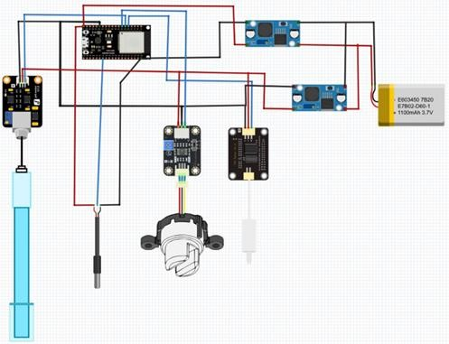
Fig. 3 Circuit diagram
  - Project Devices
The complete hardware setup for this project has been successfully developed, as illustrated in Fig. 4. The device is designed to be portable and capable of floating on the water’s surface, ensuring continuous and real-time monitoring of pool water quality. To achieve this, the enclosure is built with water-resistant materials to protect the electronic components from moisture and splashes, while maintaining buoyancy to keep the device afloat.
All sensors are strategically positioned at the bottom of the device body, where they remain submerged in the pool water to accurately measure key water quality parameters. These include pH level, turbidity, Total Dissolved Solids (TDS), and temperature. The collected data is processed by the onboard ESP32 microcontroller and transmitted via Wi-Fi to a cloud-based monitoring system. This setup allows pool owners or maintenance personnel to track water conditions remotely, ensuring that the pool remains clean and safe for users.

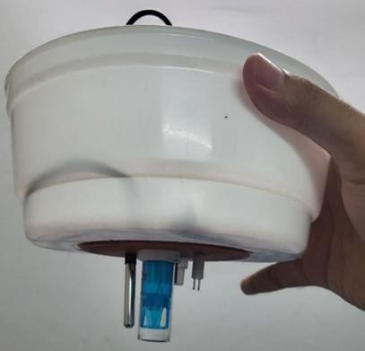 | 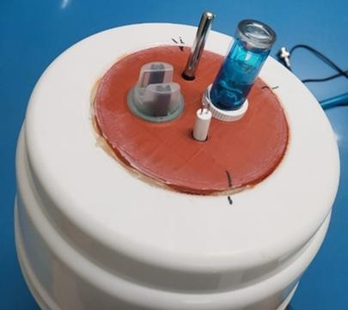
(a) | (b)

Fig. 4 Figure description (a) Project device; (b) Sensors placement
  - Software Development
Arduino Cloud is a cloud-based platform developed by Arduino to simplify the creation of IoT (Internet of Things) projects. Designed with a user-friendly interface, this platform allows users to configure devices, write and upload code, design applications, and visualize data, which all within a single integrated environment.
One of the key advantages of Arduino Cloud is its seamless compatibility with various Arduino boards and ESP-based microcontrollers, including the ESP32 used in this project. The platform provides real-time data monitoring, enabling users to track sensor readings remotely through a web dashboard or mobile application.
As shown in Fig. 5, the Arduino Cloud interface is accessible through both web browsers and mobile apps, offering a convenient and interactive way to monitor and manage connected IoT devices. This feature ensures that pool water quality data, such as pH, turbidity, TDS, and temperature, can be visualized in real time, allowing users to respond promptly to any changes.
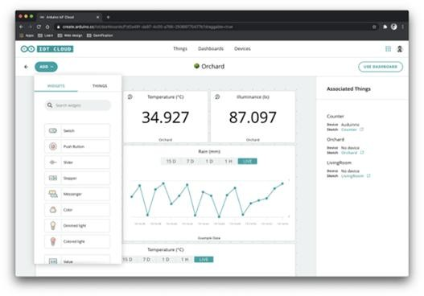
Fig. 5 Arduino cloud
  - Experiment Setup for Outdoor Swimming Pools
The first experiment began by carefully placing the developed device in a clean swimming pool under controlled conditions. This experiment was conducted at the Pusat Akuatik Negeri Kedah, located at Jalan Gunung Keriang, Alor Setar, Kedah, as shown in Fig. 6. The test took place on 25 June 2023, in the morning.
During the experiment, the device was floated on the water surface, allowing the pH, turbidity, Total Dissolved Solids (TDS), and temperature sensors to continuously monitor and collect data. The data was recorded over a one-hour period to establish baseline readings for ideal swimming pool water quality. This process aimed to verify the accuracy and reliability of the system before conducting further tests in different water conditions.experiment process starts by put the devices in clean swimming pool with good care.The experiment conducted at public swimming pool Pusat Akuatik Negeri Kedah shows in Fig. 6 at Jalan Gunung Keriang, Alor Setar Kedah, the date of experiment is on 25 June 2023 at the morning. The project device was placed on the water then collected and recorded the data needed for ideal water quality for swimming pool in one hour.

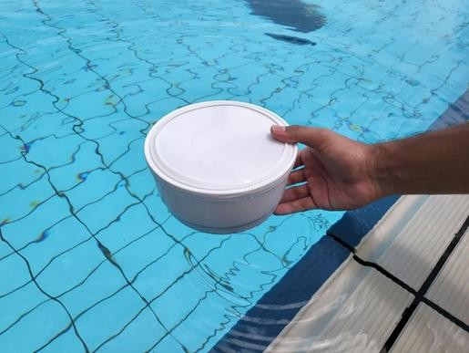
Fig. 6 Pusat Akuatik Negeri Kedah
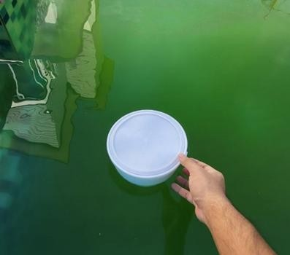
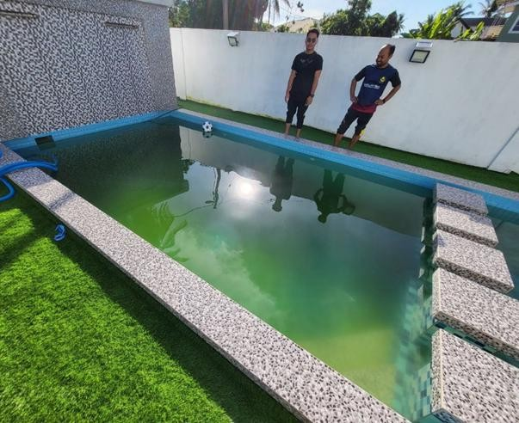
Next, Fig. 7 illustrates the experiment conducted to collect and record data from a swimming pool with poor water quality. This test was carried out at a private swimming pool on 28 June 2023, in the morning, and lasted for one hour. For this experiment, the pool had been left untreated for five days, during which the filtration system remained off, and no chemical treatments were added. As a result, the water quality deteriorated, creating an ideal environment to assess the device’s ability to detect and measure deviations in pH, turbidity, TDS, and temperature levels. The device was placed in the pool, and real-time data was recorded to analyze the effects of neglected maintenance on water quality.
Fig. 7 Swimming pool without proper maintenance
- Result and Discussion
4.1 Good Water Quality of Swimming Pools Result
Fig. 8 presents the measured parameters of a well-maintained public swimming pool. The data collected indicates that the pH value ranged between 7.6 and 7.7, which falls within the ideal range of 7.2 to 7.8 recommended for swimming pools. This balance ensures that the water remains safe and comfortable for swimmers, preventing skin and eye irritation. Additionally, the Total Dissolved Solids (TDS) levels were recorded between 922 and 924 ppm, aligning with the optimal range of 800 to 1200 ppm. This suggests that the dissolved minerals and chemicals in the water are within acceptable limits, preventing issues such as cloudiness or excessive chemical buildup.
In terms of turbidity, the measurements confirmed that the water met the clarity standard, as the turbidity value remained below 20 NTU. According to the turbidity scale used in this project, values below 20 NTU indicate clear water, demonstrating that proper filtration and chemical treatment were in place. The temperature of the pool was initially recorded at 28°C, but as the experiment progressed, the average temperature was observed to be around 29°C. This increase is likely attributed to environmental factors such as direct sunlight, as the pool was located outdoors.
From the collected data, it is evident that a well-maintained swimming pool adheres to specific conditions to ensure water quality. The ideal pH range of 7.2 to 7.8, a TDS value between 800 and 1200 ppm, and a turbidity level below 20 NTU all contribute to maintaining clear, clean, and chemically balanced water. Additionally, while temperature fluctuations are influenced by external conditions, the recorded values remained within an acceptable range for outdoor swimming pools. These findings highlight the importance of regular pool maintenance, proper chemical balance, and effective filtration systems in ensuring a safe and enjoyable swimming environment.
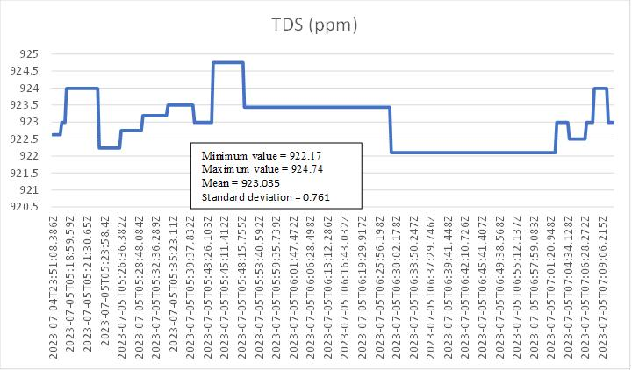
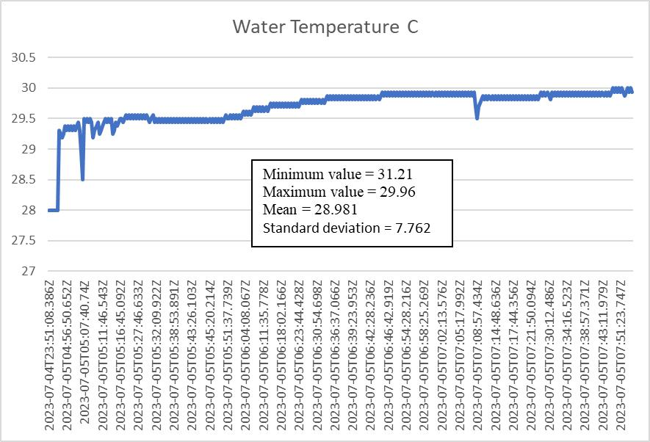
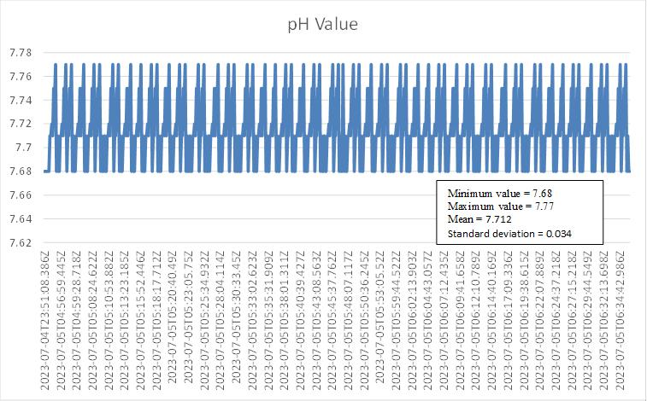

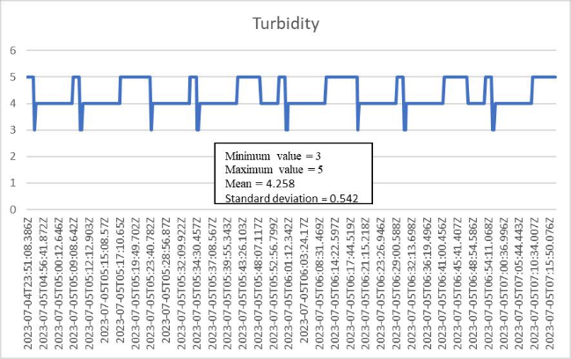

Fig. 8 pH, TDS, turbidity and water temperature value graph result for good quality swimming pool
4.2 Poor Water Quality of Swimming Pools Result
Fig. 9 presents the graph results of pH values measured from a swimming pool that was left unattended for five days. The recorded pH levels ranged between 8 and 10, which exceed the ideal range of 7.2 to 7.8. A pH level outside this optimal range can be harmful to human health, potentially causing skin and eye irritation. The Total Dissolved Solids (TDS) values recorded in the graph range from 349 ppm to 390 ppm, excluding the initial 200 ppm reading at the start. These values indicate that the swimming pool does not meet the ideal TDS range of 800 to 1200 ppm. The significantly low TDS levels suggest an imbalance or deficiency in essential chemical substances required to maintain water quality. This lack of chemical balance can contribute to the rapid deterioration of water clarity and hygiene.
Observations from the experiment revealed that when a swimming pool is left without care, the water becomes cloudy within just two days. The turbidity scale measurement from Figure 9 shows that the water turned greenish due to algae growth. The recorded turbidity values averaged around 35 NTU, which is significantly higher than the acceptable limit of 20 NTU, confirming that the water was indeed cloudy. The experiment also recorded an average temperature of 29°C, which remained consistent with the previous experiment, as the measurements were taken from an outdoor swimming pool.
These findings highlight the consequences of neglecting proper pool maintenance. When a swimming pool is not regularly treated with chemical substances such as chlorine, the TDS levels drop, leading to an imbalance in the water’s chemical composition. Insufficient chlorine levels allow algae to grow, which in turn causes the water to turn green and become cloudy. Additionally, the rise in pH levels further accelerates algae growth, making the water unsuitable for swimming. The results from this experiment align with literature findings, reinforcing the importance of maintaining proper chemical balance in swimming pools to prevent algae formation and ensure clear, safe water conditions.
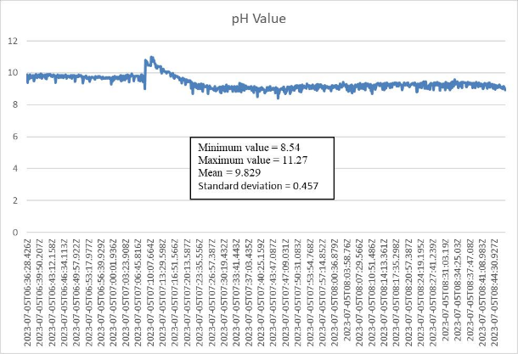
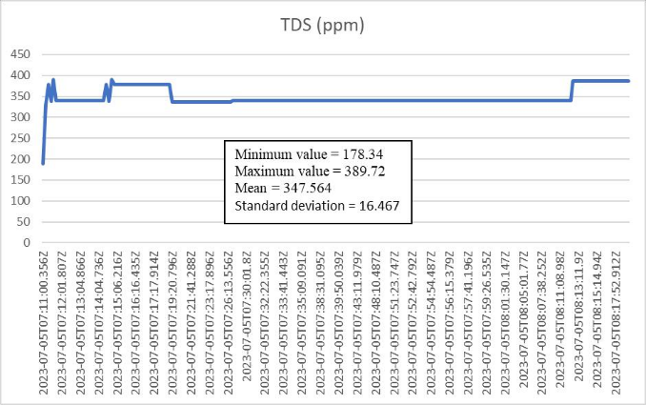
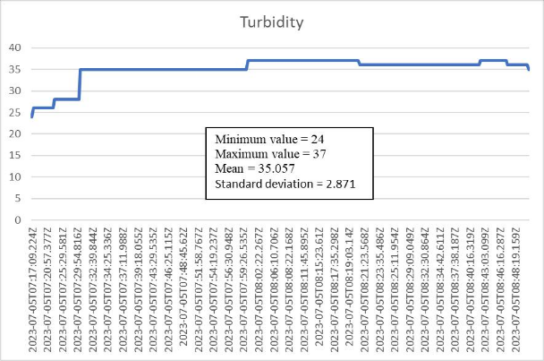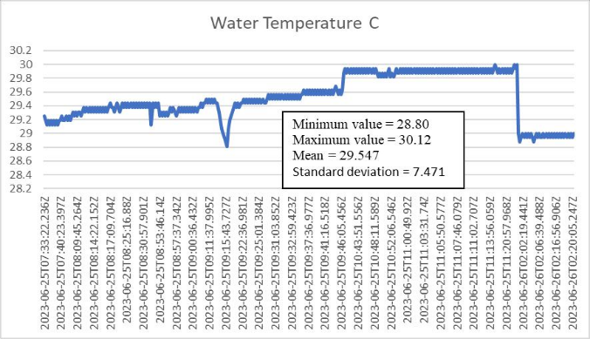

Fig. 9 pH, TDS, turbidity and water temperature value graph result for poor quality swimming pool
4.3 Discussion
Table 1 presents a comparison of data between good and poor water quality in swimming pools. In well-maintained public swimming pools, which fall under the category of good water quality, the pH, Total Dissolved Solids (TDS), and turbidity scale values remain within the ideal range, ensuring a safe and comfortable swimming environment. The proper care and maintenance carried out by pool workers, such as routine filtration, the addition of necessary chemical substances to maintain a balanced composition, and daily monitoring, help to sustain optimal water quality and meet the required safety standards. In contrast, swimming pools with poor water quality exhibit data that deviate significantly from the ideal values. The lack of maintenance leads to an environment conducive to bacterial and algae growth. The presence of algae not only causes the pool to appear green and murky but also contributes to an increase in pH levels. Additionally, TDS levels drop due to the absence of necessary chemical treatments, further disrupting the pool's chemical balance. As a result, the water becomes increasingly cloudy, leading to turbidity scale readings that exceed the acceptable threshold of 20 NTU, making the pool unsuitable for use.
Table 1 Comparison of good & poor or bad water quality data for swimming pool
Parameter | Good water quality | Bad water quality
Average pH | 7.71 | 9.83
Average TDS (ppm) | 923 | 348
Average Turbidity Scale | 4 | 35
Average Temperature (˚C) | 29 | 29
The comparison between well-maintained and neglected swimming pools reveals significant differences in water quality parameters such as pH, Total Dissolved Solids (TDS), turbidity, and overall clarity. The well-maintained pool had a pH level of 7.71, which falls within the ideal range (7.2 to 7.8), ensuring effective chlorine disinfection and swimmer comfort. In contrast, the neglected pool had a high pH of 9.83, reducing chlorine efficiency and encouraging algae growth. High pH levels can cause skin and eye irritation and lead to scaling on pool surfaces.
TDS levels further highlight the impact of maintenance on water quality. The well-maintained pool had a TDS value of 923 ppm, indicating a balanced chemical composition necessary for effective sanitization. However, the neglected pool had a drastically lower TDS level of 348 ppm, suggesting a lack of essential dissolved chemicals. This imbalance can contribute to unstable water chemistry, making it difficult to maintain proper sanitation and allowing contaminants to thrive.
Turbidity measurements reinforce the importance of regular maintenance. The well-maintained pool had a turbidity scale of 4, signifying clear water, while the neglected pool recorded a turbidity scale of 35, well above the acceptable limit. High turbidity levels indicate cloudiness caused by suspended particles and algae, which can pose health risks and reduce water visibility. Although the temperature of both pools remained constant at 29°C due to similar environmental conditions, it did not directly impact water quality but could influence microbial activity.
Overall, these findings emphasize the need for routine pool maintenance, including regular chemical treatment, filtration, and monitoring. Properly maintained pools ensure ideal pH, TDS, and turbidity levels, preventing algae growth and bacterial contamination. Neglecting maintenance leads to rapid deterioration, making the pool unsafe and unappealing. Regular care is essential to maintain healthy swimming conditions and prolong the lifespan of the pool infrastructure.
- Conclusion
The IoT-Based Swimming Pool Water Quality Monitoring System enhances the efficiency and accuracy of water quality monitoring by utilizing real-time data collection and analysis. This system provides an easy and cost-effective solution for ensuring pool safety and cleanliness. By continuously monitoring key parameters such as pH, TDS, turbidity, and temperature, it helps prevent water quality issues that could lead to health risks. The system notifies users of any abnormalities, enabling timely corrective actions to maintain optimal swimming conditions.
The system integrates sensors, controllers, and cloud-based data storage, all connected wirelessly via Wi-Fi. This connectivity allows seamless data transmission, ensuring that pool owners and operators have access to real-time water quality information. By leveraging cloud technology, the system provides reliable and consistent data analysis, reducing manual efforts while improving overall pool maintenance efficiency.
Furthermore, the integration of a website and mobile application enhances user experience and accessibility. Users can remotely monitor the pool’s water quality from any location, making it easier to maintain and manage pool conditions. This feature is particularly beneficial for public pool operators, who need to ensure compliance with health and safety standards. The user-friendly interface simplifies data interpretation, allowing for quick decision-making in response to any detected issues.
In conclusion, the IoT-Based Swimming Pool Water Quality Monitoring System represents a significant advancement in pool maintenance technology. Its ability to provide real-time data, remote monitoring, and automated alerts makes it an essential tool for maintaining clean and safe swimming environments. As IoT technology continues to evolve, this system can be further enhanced to meet changing needs, ensuring better water quality management and improved pool hygiene.
Acknowledgement
Communication of this research is made possible through monetary assistance by Universiti Malaysia Perlis Malaysia via Publication Fund.
Conflict of Interest
The authors declare that there is no conflict of interest regarding the publication of this paper. All research work, including data collection, analysis, and conclusions, was conducted objectively and without any financial or personal influences that could affect the integrity of the findings.

Author Contribution
The authors confirm their contributions to the paper as follows: Muhamad Naqib Mohd Shukri and Muhamad Khairul Ali Hassan were responsible for the study conception and design. Muhamad Khairul Ali Hassan and Fathinul Syahir Ahmad Saad conducted data collection. Muhamad Naqib Mohd Shukri, Muhamad Khairul Ali Hassan, Fathinul Syahir Ahmad Saad, and Sukhairi Sudin contributed to the analysis and interpretation of results. The draft manuscript was prepared by Muhamad Khairul Ali Hassan and Muhamad Naqib Mohd Shukri. All authors, including Khairul Salleh Basaruddin, Muhammad Juhairi Aziz Safar, Shafriza Nisha Basah, Haniza Yazid, Mohd Hanafi Mat Som, and Zhongjie Long, reviewed the results and approved the final version of the manuscript.
References
- McNally, N., Williams, H., Phillips, D., Smallman-Raynor, M., Lewis, S., Venn, A., & Britton, J. (1998). Atopic eczema and domestic water hardness. The Lancet, 352(9127), 527–531. https://doi.org/10.1016/s0140- 6736(98)01402-0
- Tsai, T.-F., & Maibach, H. I. (1999). How irritant is water? An overview. Contact Dermatitis, 41(6), 311–314. https://doi.org/10.1111/j.1600-0536.1999.tb06990.x
- Water Treatment and Testing | Healthy Swimming | Healthy Water | CDC. (2023, April 12). Www.cdc.gov. https://www.cdc.gov/healthywater/swimming/residential/disinfection- testing.html#:~:text=Third%2C%20keeping%20the%20pH%20in
- In Swimming Pool Season, Time to Check Chlorine And pH Levels. (n.d.). NPR.org. https://www.npr.org/sections/health-shots/2011/08/04/138954577/in-swimming-pool-season-time-to-check- chlorine-and-ph-levels
- K. Kulthanan, P. Nuchkull, and S. Varothai, “The pH of water from various sources: an overview for recommendation for patients with atopic dermatitis,” Asia Pac Allergy, vol. 3, no. 3, p. 155, 2013, doi: 10.5415/apallergy.2013.3.3.155.
- M. R. Tomei, F. Arduini, D. Neagu, and D. Moscone, “Carbon black-based disposable sensor for an on-site detection of free chlorine in swimming pool water,” Talanta, vol. 189, pp. 262–267, Nov. 2018, doi: 10.1016/j.talanta.2018.07.005.
- SunnyTent, “What is the ideal swimming pool temperature? How do you keep it ideal?” https://sunnytent.com/en/blog/what-is-the-ideal-swimming-pool-temperature-how-do-you-keep-it-ideal/ (accessed Nov. 21, 2023).
- Susieknifeandfork. (2022, February 28). Three Early Indicators that Algae is Blooming in the Pool | Aquaman Pools. Aquaman Pools Scottsdale. https://supercleanpools.com/three-early-indicators-that-algae-is-blooming-in- the- pool/#:~:text=Cloudy%20Water%20%E2%80%94%20If%20the%20pool,have%20found%20a%20home%20ther e!
- Daneshgar, S. and Taghizadeh, M.M. (no date) Natural methods of controlling algae growth in outdoor swimming pools, EQA. Available at: https://eqa.unibo.it/article/view/7231 (Accessed: 27 February 2025).
- Stankowitz, R. (2021). How to Get Rid of Swimming Pool Algae.
- Morris, Z. (2025) Total dissolved solids (TDS) meaning: A clear guide for pool operators, Clear Comfort. Available at: https://clearcomfort.com/total-dissolved-solids-tds-ultimate-guide-aquatic-operators/ (Accessed: 27 February 2025).
- Mohammad, W., Mohd, Nurul Syuhadah Khusaini, & Mohamed, Z. (2023). IoT based water quality monitoring system and test for swimming pool water physicochemical quality. https://doi.org/10.1063/5.0124195
- Keshipeddi, S. B. (2021). IoT Based Smart Water Quality Monitoring System. SSRN Electronic Journal. https://doi.org/10.2139/ssrn.3904842
- Bryant, S. (2017, March 3). Measuring pool water turbidity or cloudiness - why is my pool water cloudy? The Laboratory People. https://camblab.info/measuring-pool-water-turbidity-or-cloudiness-why-is-my-pool-water- cloudy/
- Saba, C. K. S., & Tekpor, S. K. (2015). Water Quality Assessment of Swimming Pools and Risk of Spreading Infections in Ghana. Research Journal of Microbiology, 10(1), 14–23. https://doi.org/10.3923/jm.2015.14.23
- Akmal Nizam Mohammed & Farzad Ismail (2013) Study of an entropy-consistent Navier-Stokes flux, International Journal of Computational Fluid Dynamics, 27(1), 1-14, https://doi.org/10.1080/10618562.2012.752573
- Ismail, F.A. et al. (2021) ‘An IOT agricultural system for Harumanis Farm’, Journal of Physics: Conference Series, 2107(1), p. 012038, https://doi.org/10.1088/1742-6596/2107/1/012038
- Zaini, M.F. et al. (2024) ‘An IOT-based system to monitor soil parameter of Harumanis Tree’, Lecture Notes in Mechanical Engineering, pp. 241–255, https://doi.org/10.1007/978-981-97-0169-8_18

